Azure Networking
- Connect cloud and on-premises
- On-premise networking functionality

Azure Virtual Network
- Logically isolated networking components
- Segmented into one or more subnets
- Subnets are discrete sections
- Enable communication of resources with each-other, internet and on-premises
- Scoped to a single region
- VNet Peering or VPN Gateway allow cross VNet communication
- Isolation, Segmentation, Communication, Filtering, Routing
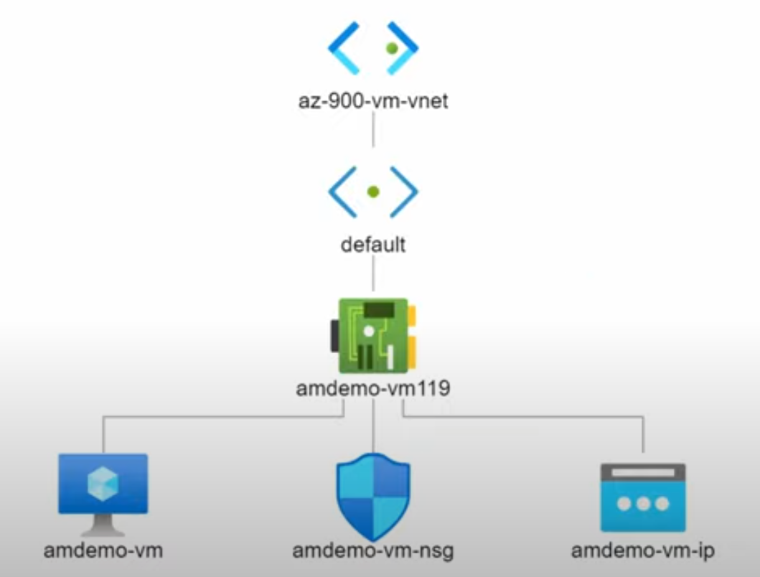
Azure Network Infrastructure Diagram Demo

VPN Gateway
- Specific type of virtual network gateway for on-premises to azure traffic over the public internet
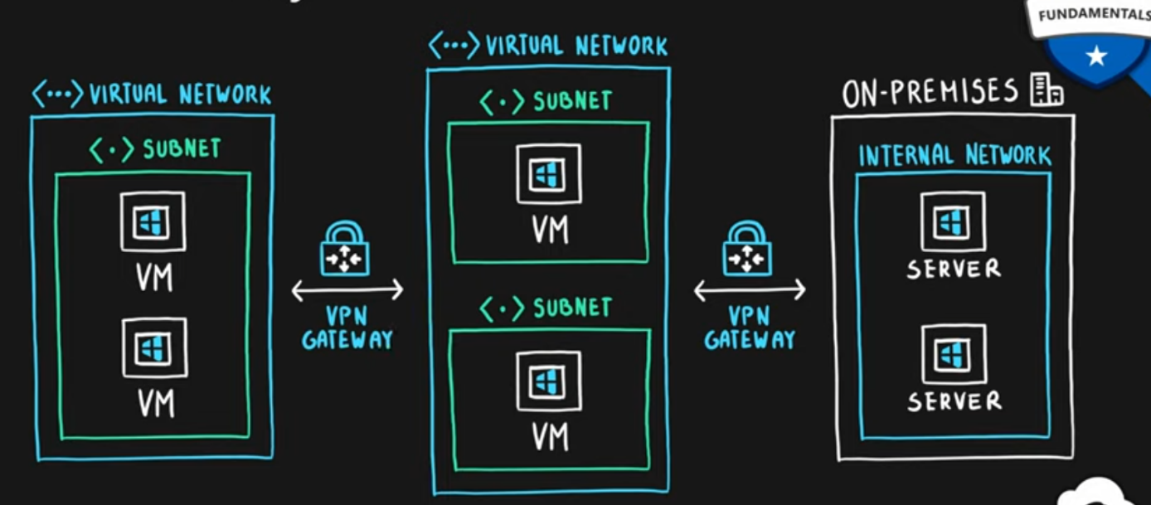

Azure Load Balancer
- Even traffic distribution
- Supports both inbound and outbound scenarios
- High-availability scenarios
- Both TCP (transmission control protocol) and UDP (user datagram protocol) applications
- Internal and External traffic
- Port Forwarding
- High scale with up to millions of flows
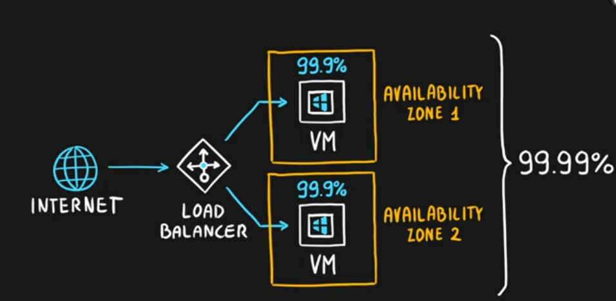
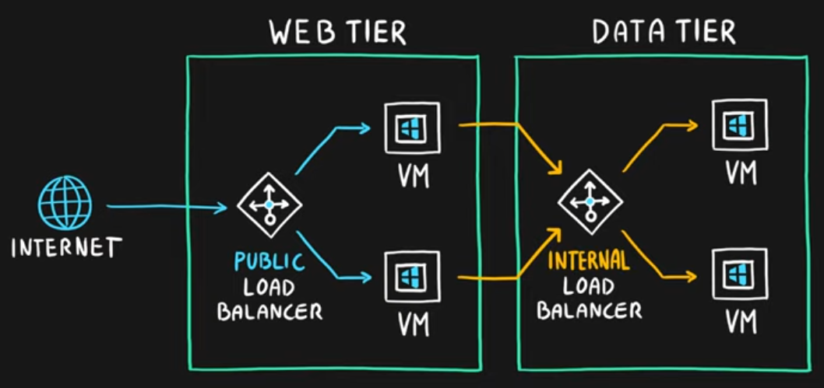

Application Gateway
- Web traffic load balancer
- Web application firewall
- Redirection
- Session affinity
- URL Routing
- SSL termination
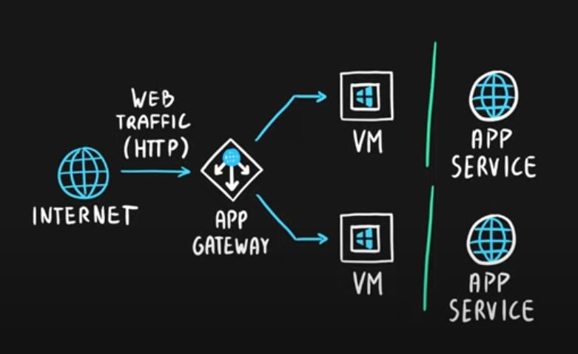
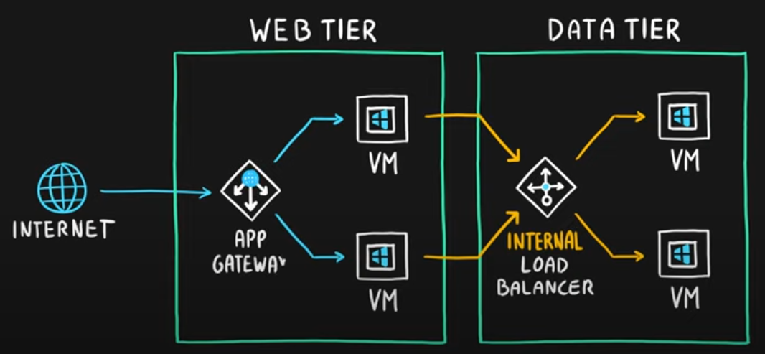

Content Delivery Network
- Define content
- Minimize latency
- POP (points of presence) with many locations
